

American International University-Bangladesh (AIUB)  
**Department of Computer Science  
Faculty of Science & Technology (FST)**

**Public Transport Optimization**

A Software Engineering Project Submitted

By

|  |  |  |  |  |
| --- | --- | --- | --- | --- |
| **Semester: Summer_21_22** | | **Section:** | **Group Number:** | |
| SN | Student Name | Student ID | Contribution (CO3+CO4) | Individual Marks |
| 01 | SAZID – AL – ABEDIN | 22-45999-1 |  |  |
| 02 | MD. SAIDUZZAMAN SOHAG | 22-46006-1 |  |  |
| 03 | MD. SADMAN HOSSAIN | 22-46061-1 |  |  |
| 04 | NOUROZE TARANNUM ANANNYA | 22-46062-1 |  |  |
| 05 | SEEMANTA TORAFDAR | 21-45968-3 |  |  |

The project will be Evaluated for the following Course Outcomes

|  |  |  |
| --- | --- | --- |
| **CO3:** *Select* appropriate software engineering models, project management roles and their associated skills for the complex software engineering project and evaluate the sustainability of developed software, taking into consideration the societal and environmental aspects | Total Marks | |
|  | |
| Appropriate Process Model Selection and Argumentation with Evidence | [5 Marks] |  |
| Evidence of Argumentation regarding process model selection | [5Marks] |  |
| Analysis the impact of societal, health, safety, legal and cultural issues | [5Marks] |  |
| Submission, Defense, Completeness, Spelling, grammar and Organization of the Project report | [5Marks] |  |
| **CO4:** *Develop* project management plan to manage software engineering projects following the principles of engineering management and economic decision process | Total Marks | |
|  | |
| Develop the project plan, its components of the proposed software products | [5Marks] |  |
| Identify all the activities/tasks related to project management and categorize them within the WBS structure. Perform detailed effort estimation correspond with the WBS and schedule the activities with resources | [5Marks] |  |
| Identify all the potential risks in your project and prioritize them to overcome these risk factors. | [5Marks] |  |

Description of Student’s Contribution in the Project work

|  |
| --- |
| Student Name: SAZID – AL – ABEDIN  Student ID: 22-45999-1  Contribution in Percentage (%):  Contribution in the Project:   * Contribution Description 1 * Contribution Description 2   ___________________  Signature of the Student |
| Student Name: MD. SAIDUZZAMAN SOHAG  Student ID: 22-46006-1  Contribution in Percentage (%):  Contribution in the Project:   * Contribution Description 1 * Contribution Description 2   ___________________  Signature of the Student |
| Student Name: MD. SADMAN HOSSAIN  Student ID: 22-46061-1  Contribution in Percentage (%):  Contribution in the Project:   * Contribution Description 1 * Contribution Description 2   ___________________  Signature of the Student |
| Student Name: NOUROZE TARANNUM ANANNYA  Student ID: 22-46062-1  Contribution in Percentage (%):  Contribution in the Project:   * Contribution Description 1 * Contribution Description 2   ___________________  Signature of the Student |
| Student Name: SEEMANTA TORAFDAR  Student ID: 21-45968-3  Contribution in Percentage (%):  Contribution in the Project:   * Contribution Description 1 * Contribution Description 2   ___________________  Signature of the Student |

# Class Diagram:

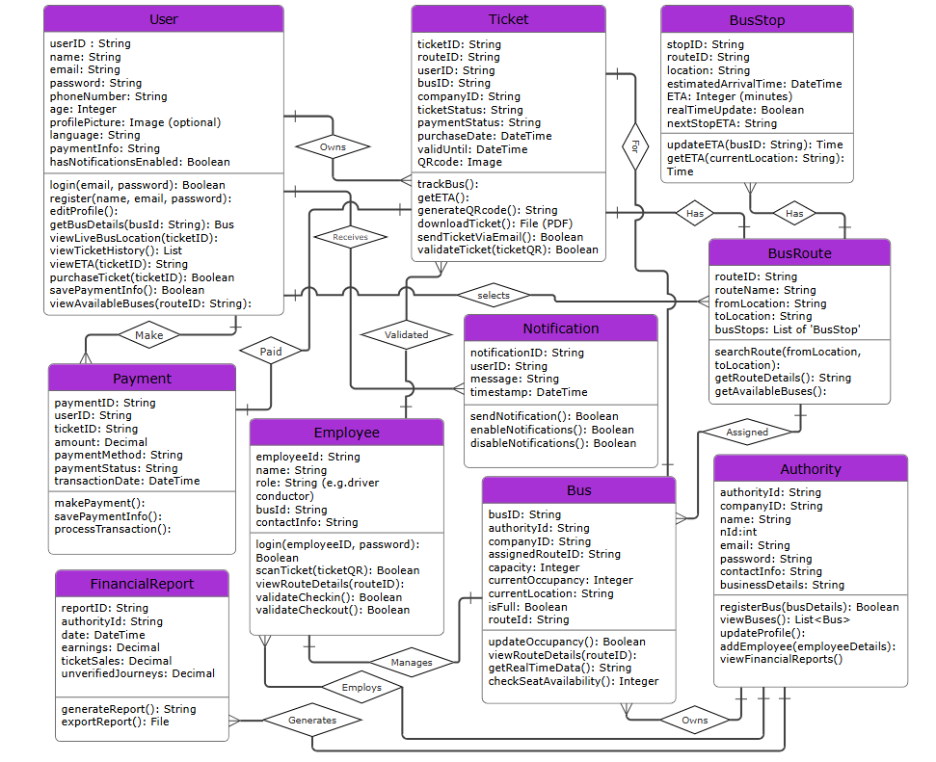

# Use Case Diagram:

